**KING FAHD UNIVERSITY OF PETROLEUM AND MINERALS-DEPARTMENT OF PHYSICS**

**PHYS 441-221**

**QUIZ # 7 Solutions**

**15-12-2022**

**10 minutes**

**1 point per question**

**Give brief answers**

**Name ID**

1. **Why was there a need to mix the current generated by the 3rd component of weak isospin $\left(j_{μ}^{3}\right)$ and the electromagnetic current $j_{μ}^{em}$?**

**Answer: The *Z* boson interacts with L as well as R handed fermions**

1. **What is the symmetry group of the electroweak interactions?**

**Answer: $SU{\left(2\right)}_{L}⊗U{\left(1\right)}_{Y}$**

1. **What are the covariant derivatives for QED and QCD?**

**Answer:**

**QED:**

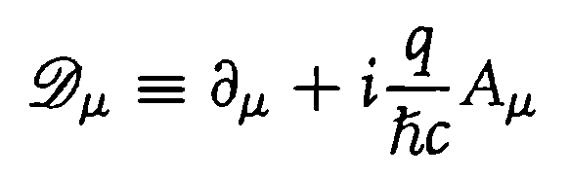

**---------------------**

**QCD:**

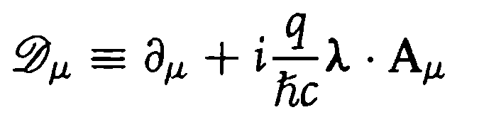

1. **Why must the gauge bosons be massless?**

**Answer: To preserve gauge invariance of the lagrangian density**

1. **Explain qualitatively how the $W^{±}$ and $Z$ gauge bosons get their masses?**

**Answer: spontaneous symmetry breaking and gauge invariance of the lagrangian density, also known as Higgs mechanism.**